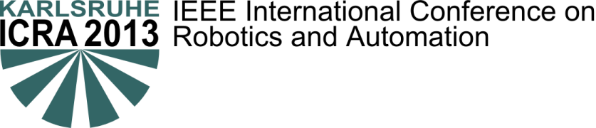

Workshop/Tutorial
Title
Organizers: A. Derpington, B. Herp, C. Derp, D. Herpington
http://www.link-to-this-workshop.edu

Objectives (max. 2000 characters)
Lorem ipsum dolor sit amet, consetetur sadipscing elitr, sed diam nonumy eirmod tempor invidunt ut labore et dolore magna aliquyam erat, sed diam voluptua. At vero eos et accusam et justo duo dolores et ea rebum. Stet clita kasd gubergren, no sea takimata sanctus est Lorem ipsum dolor sit amet. Lorem ipsum dolor sit amet, consetetur sadipscing elitr, sed diam nonumy eirmod tempor invidunt ut labore et dolore magna aliquyam erat, sed diam voluptua. At vero eos et accusam et justo duo dolores et ea rebum. Stet clita kasd gubergren, no sea takimata sanctus est Lorem ipsum dolor sit amet.

Topics of interest
- Topic
- Topic
- …

Invited Speakers:
- Name, Affiliation
- Name, Affiliation
- …

This workshop is supported by IEEE RAS Technical Committee on ...

Program
Time | Talk
8:30 | Talk 1
10:00 - 10:30 | Coffee Break
12:50 - 14:00 | Lunch Break
15:30 - 16:00 | Coffee Break
18:20 | End

Organizers
A. Derpington
Evergreenterrace 21
Springfield
derpington@herpderp.com
B. Herp
Evergreenterrace 21
Springfield
herp@herpderp.com
C. Derp
Evergreenterrace 21
Springfield
derp@herpderp.com
D. Herpington
Evergreenterrace 21
Springfield
herpington@herpderp.com

Contact
A. Derpington
Evergreenterrace 21
Springfield
derpington@herpderp.com

